Deep learning-assisted prediction of glass transition temperature in polymers

1st Vaishavi Srivastava
dl.ai.u4aid24137@dl.students.amrita.edu
4th Nanduri Venkata Sesha Abhiram
dl.ai.u4aid24124@dl.students.amrit
a.edu

2nd Vaishnavi Srivastava
dl.ai.u4aid24138@dl.students.amrita.edu
3rd Medam Madhava Sresti
dl.ai.u4aid24122@dl.students.amrita.edu

Abstract
The glass transition temperature (Tg) is a critical thermal property of polymers that determines their mechanical strength, flexibility, durability, and thermal stability. Accurate prediction of Tg is essential in applications such as aerospace, automotive, electronics, packaging, and biomedical materials. Traditional experimental techniques used for Tg measurement are often time-consuming, expensive, and difficult to scale for large polymer datasets. To address these limitations, this work proposes a hybrid deep learning framework for predicting the Tg of polymers using molecular structure information and physicochemical descriptors.

The proposed approach combines SMILES-based sequence learning with RDKit-generated molecular descriptors to capture both sequential and chemical characteristics of polymers. The dataset was preprocessed by removing duplicates, handling missing values, and eliminating invalid SMILES structures. Nine molecular descriptors, including molecular weight, TPSA, hydrogen bond donors and acceptors, and number of heavy atoms, were extracted using RDKit. The SMILES strings were tokenized, integer encoded, and padded before being processed by the deep learning model.

The developed architecture consists of an Embedding layer, Bidirectional LSTM, Attention mechanism, Global Average Pooling, and dense layers integrated with molecular descriptor inputs. The model was trained using the Adam optimizer and Mean Squared Error (MSE) loss function. Experimental evaluation on the TgSS enriched polymer dataset achieved a Test MAE of 26.22 and an R² score of 0.8891, demonstrating strong predictive performance on unseen polymer samples.

The obtained results show that combining sequential molecular learning with physicochemical descriptors significantly improves Tg prediction accuracy. The proposed framework provides a fast and cost-effective alternative to traditional experimental methods and demonstrates the potential of deep learning techniques in accelerating polymer material discovery and property prediction.

Introduction
The glass transition temperature (Tg) is a fundamental thermophysical property that governs the mechanical behavior, thermal stability, and processing conditions of polymers and organic materials. Accurate prediction of Tg is essential for material design and industrial applications; however, it remains a complex challenge due to its dependence on molecular structure, chain mobility, and thermodynamic history. Conventional experimental techniques such as differential scanning calorimetry and dynamic mechanical analysis are widely used but are often time-consuming, costly, and limited in scalability [1]. Consequently, there has been a growing interest in computational and data-driven approaches for efficient and reliable Tg prediction.

Among computational approaches, molecular dynamics (MD) simulations have been widely employed to estimate Tg by modeling the transition from glassy to rubbery states. Recent studies utilizing ensemble-based MD simulations have demonstrated improved reproducibility and reduced uncertainty, achieving good agreement with experimental observations. However, these approaches require significant computational resources and long simulation times, which limit their applicability for high-throughput screening and large-scale material discovery [2]. As a result, machine learning (ML) methods have emerged as a promising alternative for establishing structure–property relationships in Tg prediction.

Several ML-based models have been proposed in recent literature. Armeli et al. developed an Extra Trees-based model using molecular descriptors and SMILES-derived features, achieving a mean absolute error (MAE) of approximately 12–13°C, with SMILES-based inputs showing slightly improved performance over descriptor-based approaches [3]. Similarly, Chen et al. introduced a chemical language processing model that utilizes SMILES representations as sequential inputs to recurrent neural networks, eliminating the need for explicit descriptor calculation and improving computational efficiency [4]. However, this approach relies solely on sequence-based information and may neglect important physicochemical features. Furthermore, Fatriansyah et al. conducted a comparative study of multiple ML models, including KNN, SVR, XGBoost, ANN, and RNN, and reported that although ANN achieved the highest predictive accuracy, XGBoost demonstrated superior stability and computational efficiency, indicating that simpler models can outperform deep learning approaches in certain cases [1]. More recently, Liu et al. proposed a hybrid framework combining generative adversarial networks (GAN) with automated machine learning (AutoML), which significantly improved prediction performance by augmenting small datasets; however, this approach introduces additional complexity and potential bias due to synthetic data generation [5].

Despite these advancements, existing approaches exhibit notable limitations. Descriptor-based models often fail to capture the sequential and contextual nature of molecular structures, while SMILES-based deep learning models do not explicitly incorporate physicochemical descriptors. Simulation-based methods, although accurate, are computationally expensive, and GAN-based frameworks increase model complexity while reducing interpretability. Therefore, there remains a need for a unified and efficient framework that can effectively integrate both molecular sequence information and chemical descriptors while maintaining strong generalization performance.

To address these challenges, the present work proposes a hybrid deep learning framework that combines SMILES-based sequence modeling with molecular descriptor features. In this approach, SMILES strings are tokenized and processed using an embedding layer followed by a bidirectional long short-term memory (BiLSTM) network with an attention mechanism to capture long-range structural dependencies. Simultaneously, molecular descriptors such as molecular weight, topological polar surface area, and hydrogen bonding characteristics are extracted and incorporated as complementary inputs. These features are then concatenated and passed through fully connected layers with dropout regularization to predict Tg values. The model is trained using the Adam optimizer with mean squared error loss and evaluated using mean absolute error on test data. Compared to existing approaches, this framework integrates the strengths of both chemical language processing models and descriptor-based quantitative structure–property relationship (QSPR) methods while avoiding the need for computationally expensive simulations or synthetic data generation.

In comparison with prior work, the proposed model achieves a mean absolute error of approximately 26, which, although higher than the best-performing descriptor-based models, demonstrates improved generalization across diverse polymer structures without relying on additional external variables such as melting temperature or artificially generated data. This highlights the robustness and scalability of the proposed approach, making it a promising contribution to polymer informatics and data-driven materials design.

Methodology
The proposed work focuses on predicting the glass transition temperature (Tg) of polymers using a hybrid deep learning framework that combines molecular descriptor features with sequential information extracted from SMILES representations. The complete methodology includes dataset preparation, preprocessing, feature extraction, sequence encoding, train–test splitting, model development, training, and performance evaluation.

Initially, the polymer dataset was collected from a structured CSV file containing Polymer Class, SMILES notation, and Tg values. Data preprocessing was performed to improve consistency and reliability by removing duplicate entries, handling missing values, and filtering invalid molecular structures. Polymer class labels were standardized to maintain uniformity throughout the dataset.

For molecular feature extraction, the RDKit library was used to convert SMILES strings into molecular objects and calculate important physicochemical descriptors. A total of 9 descriptor features were utilized, including molecular weight, number of atoms, number of bonds, topological polar surface area (TPSA), ring count, hydrogen bond donors, hydrogen bond acceptors, and related structural properties affecting polymer thermal behavior.

The SMILES strings were transformed into numerical sequences using character-level tokenization. Each character was mapped to a unique integer index, and padding was applied to ensure a fixed sequence length of 314 for all input sequences. Descriptor features were normalized using standard scaling methods, while Tg values were scaled to stabilize the learning process and improve model convergence.

After preprocessing, the dataset was divided into training and testing subsets using an 80:20 split ratio. Approximately 80% of the data was used for training the model, while the remaining 20% was reserved for testing and evaluating prediction performance on unseen samples. A validation subset was further used during training to monitor model generalization and reduce overfitting.

A hybrid functional neural network architecture was implemented using TensorFlow and Keras. The first input branch processed tokenized SMILES sequences through an Embedding layer with an output dimension of 64. The embedding layer produced an output shape of (None, 314, 64) with 2,624 trainable parameters. The embedded sequences were then passed into a Bidirectional LSTM layer with 128 output features, generating an output shape of (None, 314, 128) and containing 66,048 trainable parameters.

To improve contextual learning, an Attention mechanism was incorporated after the Bidirectional LSTM layer, enabling the network to focus on chemically significant regions within the molecular sequence. The attention output was passed through a Global Average Pooling layer, reducing it to a fixed-length feature vector of size 128. A Dropout layer was included to minimize overfitting during training.

The second input branch accepted the 9 molecular descriptor features directly as numerical inputs. Outputs from both branches were merged using a Concatenate layer, producing a combined feature vector of size 137. This merged representation was then passed through a Dense layer containing 128 neurons with 17,664 trainable parameters, followed by another Dropout layer for regularization. Finally, a Dense output layer with a single neuron and 129 trainable parameters was used to predict the Tg value.

The complete network consisted of 86,465 trainable parameters with a total memory size of approximately 337.75 KB. The model was trained using the Adam optimizer and Mean Squared Error (MSE) loss function. Early stopping was implemented to restore the best-performing weights when validation loss stopped improving.

The performance of the proposed model was evaluated using Mean Absolute Error (MAE), Root Mean Squared Error (RMSE), and coefficient of determination (R² score). In addition, graphical analyses such as Tg distribution plots, correlation heatmaps, and predicted-versus-actual comparison graphs were used to study dataset behavior and evaluate prediction accuracy.

The proposed methodology effectively combines sequential molecular learning with physicochemical descriptor analysis, enabling accurate prediction of polymer glass transition temperatures through a deep learning-based hybrid architecture.

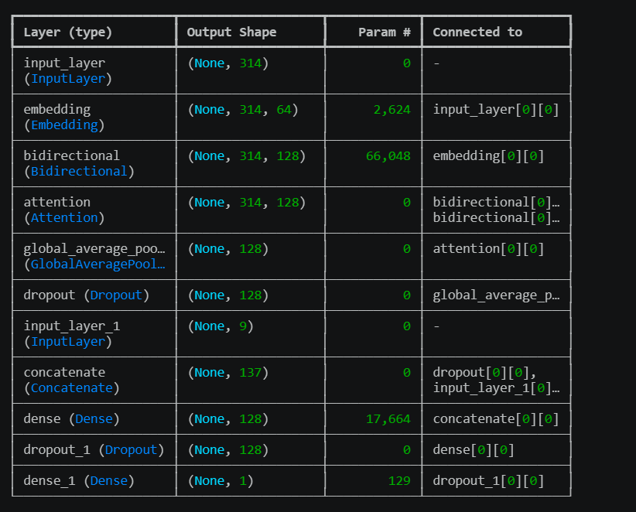
Figure -1
BiLSTM-based Hybrid Model for Tg Prediction

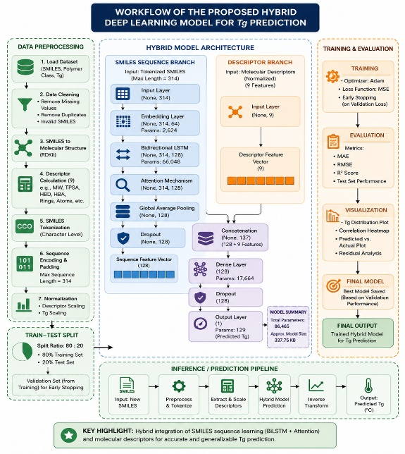
Figure – 2
Proposed Methodology for SMILES and Descriptor-Based Tg Prediction

results
The proposed hybrid deep learning model was evaluated on the TgSS enriched polymer dataset containing 7,284 polymer samples with SMILES representations, Tg values, and polymer class information. The dataset included polymers with both low Tg values representing flexible and rubbery materials, and high Tg values representing rigid and thermally stable materials. Polyacrylics and Polyvinyls were observed to be the most common polymer classes in the dataset.
The model successfully learned the relationship between polymer molecular structure and glass transition temperature using both SMILES sequence information and molecular descriptors. The hybrid architecture achieved a Test MAE of 26.22 and a Test R² score of 0.8891, indicating strong predictive capability and good generalization performance on unseen data.
The Actual vs Predicted Tg(figure -5) graph showed that most prediction points were concentrated near the diagonal line, demonstrating close agreement between experimental and predicted Tg values. This indicates that the model effectively captured important molecular patterns influencing polymer thermal behavior.
The error distribution graph(figure – 6) revealed that a large number of polymers had low prediction error values, suggesting that the proposed model produced accurate predictions for most polymer samples. The prediction analysis table grouped by polymer class further showed variations in mean and median prediction errors across different polymer families.
The MAE curve(figure – 3) demonstrated a steady decrease during training, indicating stable learning and convergence of the model. Similarly, the training and validation loss curves followed closely with only a small gap between them, suggesting minimal overfitting and good generalization ability. The MAE stabilized in later epochs, confirming that the network had successfully converged during training.
The box plot visualization of Tg(figure – 9) distributions across polymer classes highlighted significant variation in thermal properties among different polymer families. Polymer classes such as Polyimides and Polyvinyls exhibited wider Tg ranges, while classes like Polysiloxanes showed comparatively lower Tg values. These visualizations demonstrate the complexity of polymer property prediction and justify the use of advanced deep learning models.

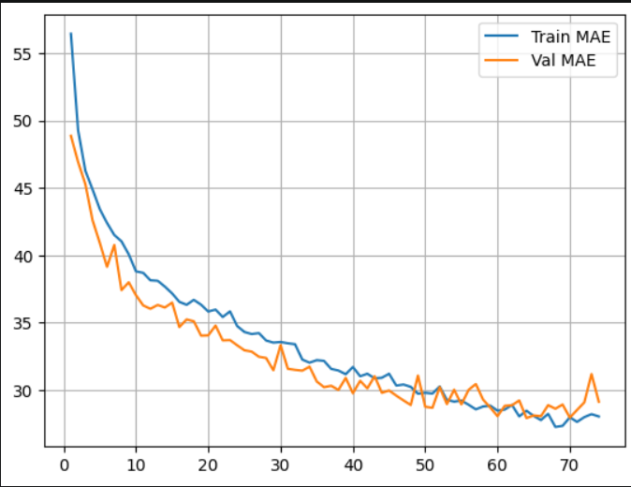
Figure – 3
Training and Validation MAE Curve

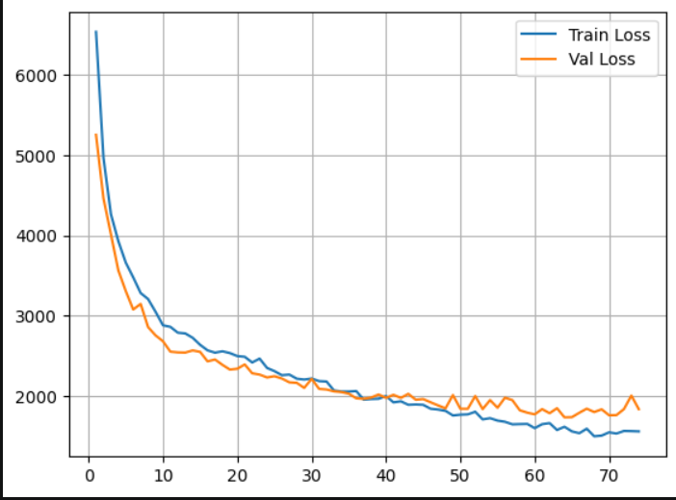
Figure – 4
Train and validation loss calculation

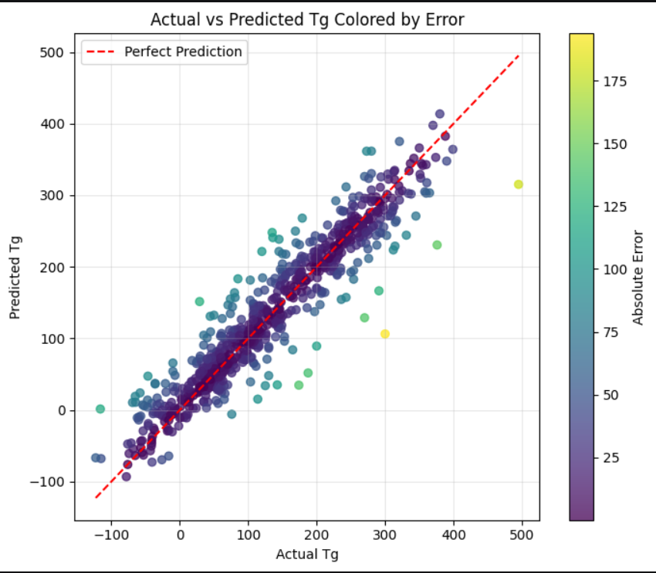
Figure – 5
Actual vs Predicted Tg Plot

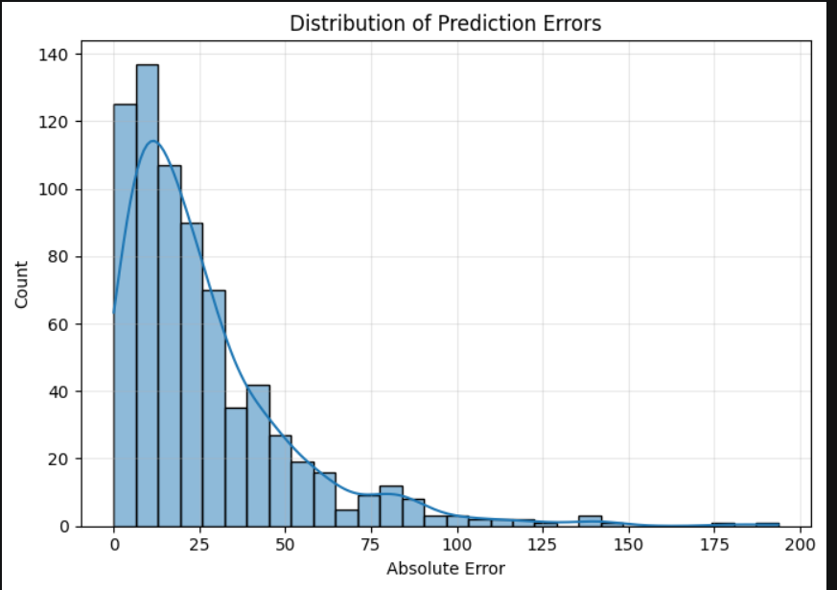

Figure – 6
Count vs Absolute error

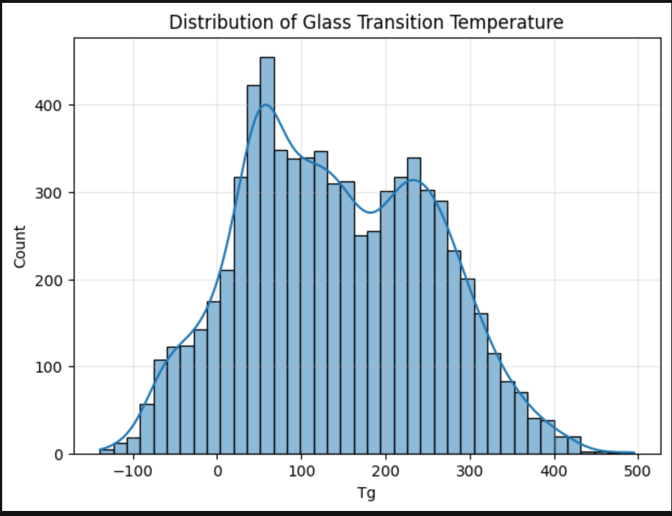
Figure – 7
Distribution of Glass Transition temperature

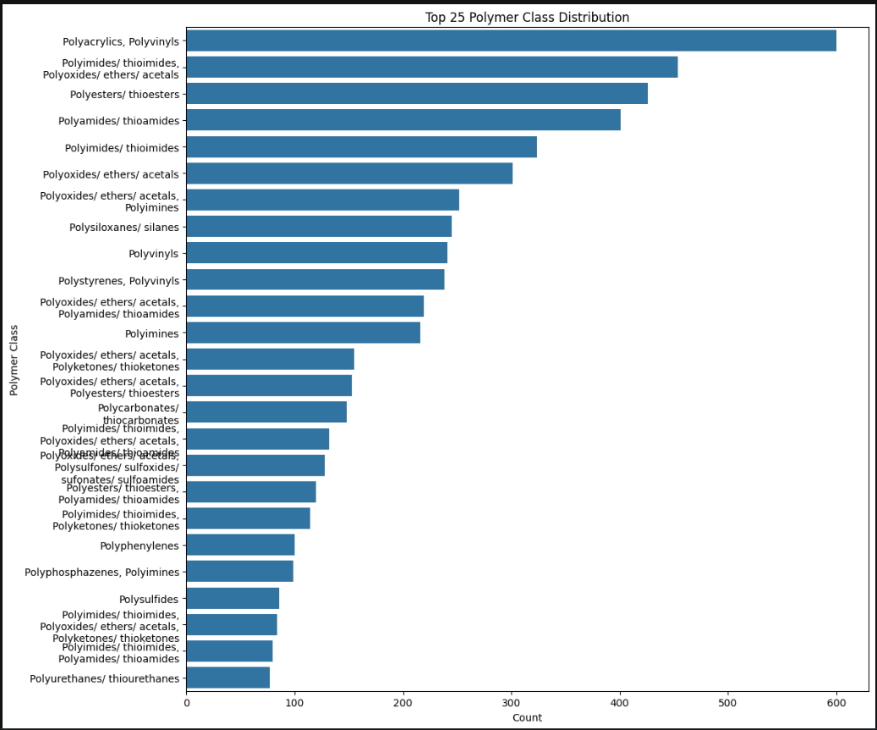
Figure – 8
Polymer class distribution

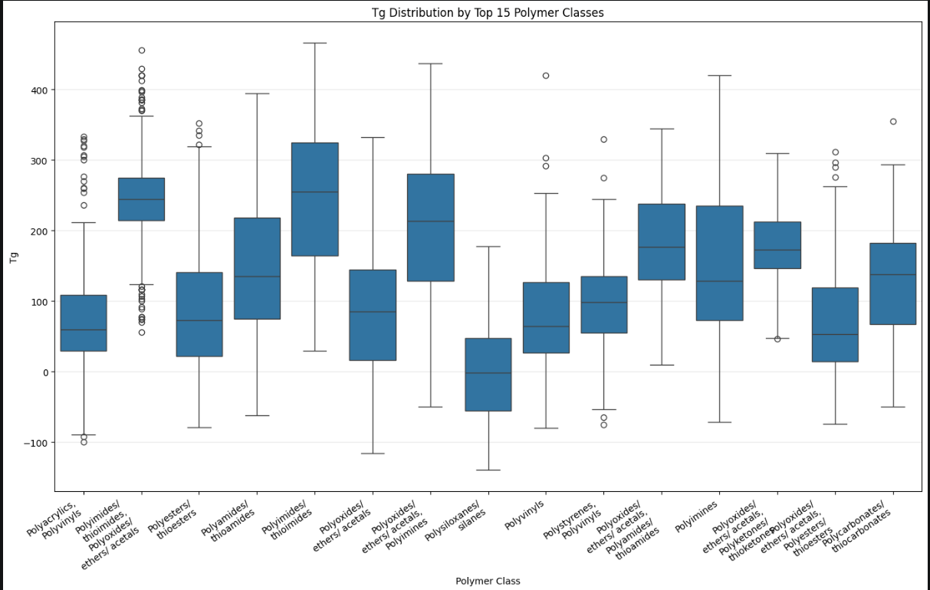
Figure – 9
T(g) Distribution

Discussion
The results obtained from the proposed hybrid deep learning framework demonstrate that combining sequence-based molecular learning with physicochemical descriptor analysis improves the prediction of polymer glass transition temperature. The Bidirectional LSTM effectively captured contextual relationships within SMILES sequences, while the Attention mechanism enabled the model to focus on chemically significant regions contributing to Tg prediction.
The achieved R² score of 0.8891 indicates that the proposed framework was able to explain a significant portion of the variance in Tg values across diverse polymer classes. Compared to traditional machine learning approaches, the hybrid architecture provided improved capability in learning complex nonlinear relationships between polymer structure and thermal behavior.
The graphical analyses also support the effectiveness of the model. The Actual vs Predicted plot confirmed strong agreement between predicted and experimental Tg values, while the MAE and Loss curves indicated stable convergence with minimal overfitting. These observations suggest that the use of dropout layers, feature normalization, and attention mechanisms contributed positively to model generalization.
However, certain limitations were observed during experimentation. Some polymer classes showed higher prediction errors due to limited representation in the dataset or the presence of rare chemical structures. Additionally, SMILES representations are linear encodings of molecular structures and may not fully capture three-dimensional polymer interactions that influence Tg behavior.
Another challenge arises from the dataset itself, as it contains polymer class labels instead of exact polymer identities. Different polymers within the same class can possess significantly different thermal properties, which may reduce prediction precision for highly diverse categories. Despite these limitations, the proposed model demonstrates strong potential as a fast and cost-effective alternative to experimental Tg measurement techniques.
Future improvements such as Graph Neural Networks (GNNs), Transformer-based architectures, larger datasets, and advanced polymer-specific descriptors may further improve model accuracy and generalization for complex polymer systems.

Conclusion
This work presented a hybrid deep learning framework for predicting the glass transition temperature (Tg) of polymers using SMILES representations and RDKit-based molecular descriptors. The proposed approach successfully combined sequence learning through Embedding, Bidirectional LSTM, and Attention mechanisms with physicochemical descriptor analysis to capture both structural and chemical characteristics of polymers.
Experimental evaluation demonstrated strong predictive performance with a Test MAE of 26.22 and an R² score of 0.8891 on unseen test data. The graphical analyses, including Actual vs Predicted Tg plots, MAE curves, loss curves, and polymer class distribution visualizations, confirmed the effectiveness and stability of the proposed model.
The results indicate that deep learning-based hybrid architectures can provide reliable and efficient Tg prediction while reducing dependence on expensive and time-consuming experimental procedures. Although minor limitations related to dataset diversity and SMILES representation were observed, the model demonstrated good generalization capability across different polymer classes.
Overall, this study highlights the potential of artificial intelligence and deep learning techniques in accelerating polymer property prediction, material discovery, and industrial polymer design. Future work involving Graph Neural Networks, Transformer models, and advanced feature engineering may further enhance prediction accuracy and scalability for real-world polymer applications.

refrences

[1] J. F. Fatriansyah et al., “Prediction of Glass Transition Temperature of Polymers Using Simple Machine Learning,” Polymers, vol. 16, 2024.

[2] J. L. Suter et al., “Rapid, Accurate and Reproducible Prediction of the Glass Transition Temperature Using Ensemble-Based Molecular Dynamics Simulation,” J. Chem. Theory Comput., 2025.

[3] G. Armeli, J.-H. Peters, and T. Koop, “Machine-Learning-Based Prediction of the Glass Transition Temperature of Organic Compounds Using Experimental Data,” ACS Omega, 2023.

[4] G. Chen, L. Tao, and Y. Li, “Predicting Polymers’ Glass Transition Temperature by a Chemical Language Processing Model,” Polymers, vol. 13, 2021.

[5] Z. Liu et al., “Predicting the Glass Transition Temperature of Polymer Based on Generative Adversarial Networks and Automated Machine Learning,” MGE Advances, 2024.

[6] Z. Long, H. Lu, and Z. Zhang, “Large-scale glass-transition temperature prediction with an equivariant neural network for screening polymers,” ACS Omega, vol. 9, pp. 5452–5462, 2024.

[7] J. Schut, D. Bolikal, I. Khan, A. Pesnell, A. Rege, R. Rojas, L. Sheihet, N. S. Murthy, and J. Kohn, “Glass transition temperature prediction of polymers through the mass-per-flexible-bond principle,” Polymer, vol. 48, no. 20, pp. 6115–6124, 2007.

[8] Y. Wang, C. Yang, X. Sun, F. Li, W. Zhao, L. Xia, and S. Xiang, “Data-driven models toward polymer glass transition temperature embedded in structures,” SSRN Preprint, 2023.

[9] N. Wolfe and F. Khabaz, “Prediction of glass transition temperature of polymers using structure-based models,” Williams Honors College, University of Akron, 2025.

